**AWS CLI installation in linux and Managing instance via CLI**

Steps to install aws CLI

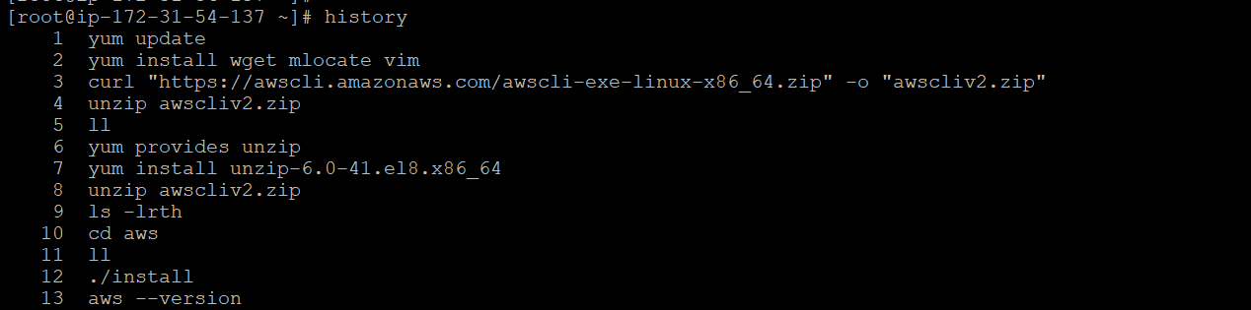

Goto IAM 🡪 choose Myaccesskey 🡪 find your access key if not create it 🡪 this for aws CLI configuration.

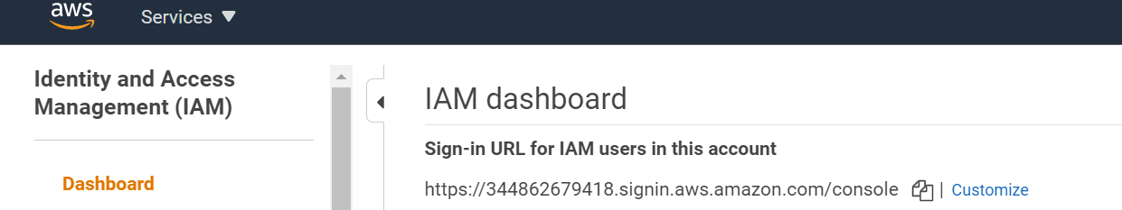

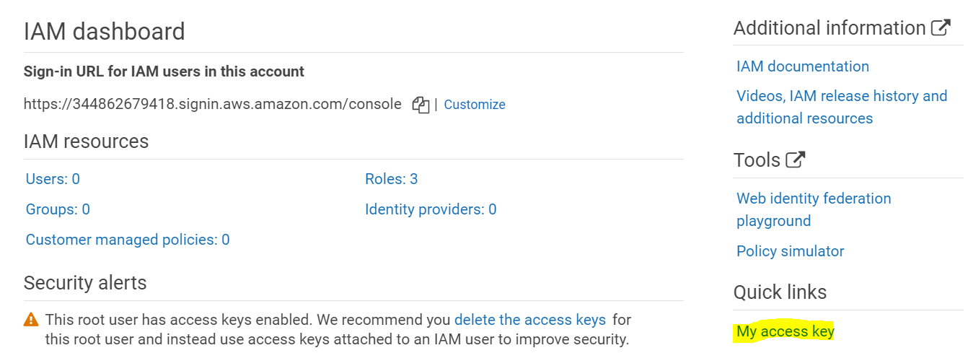

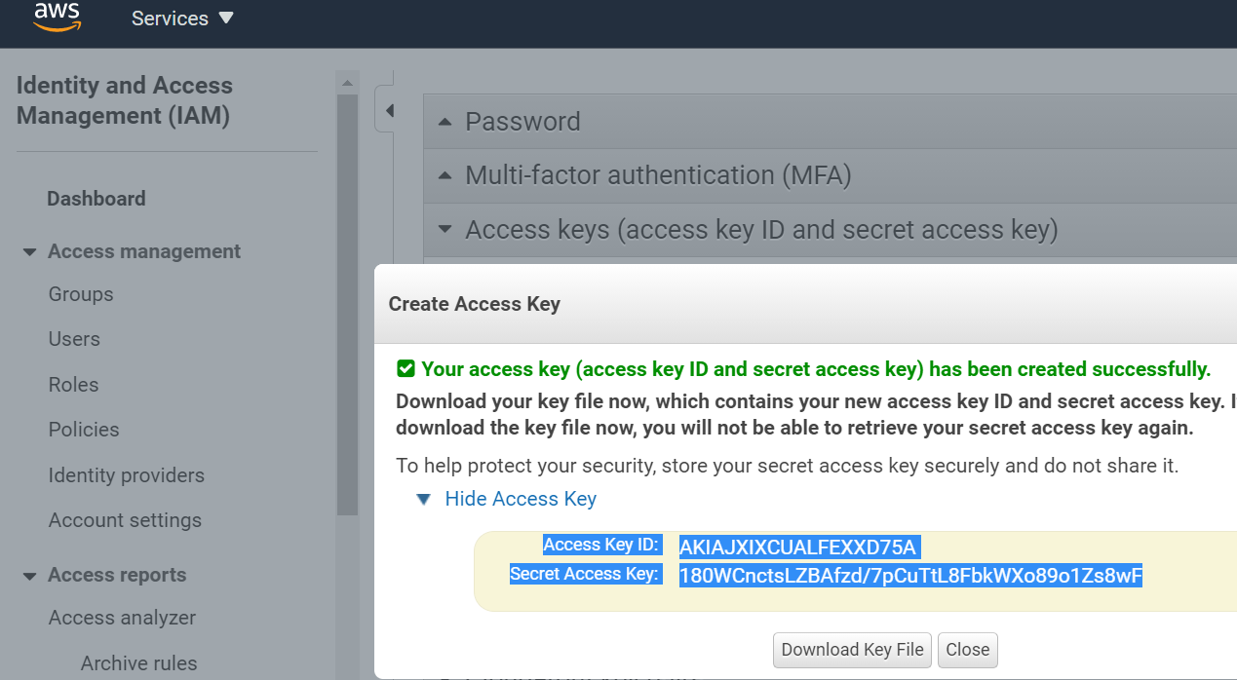

Configure aws CLI and manage the instances

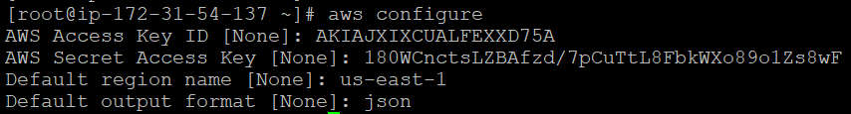

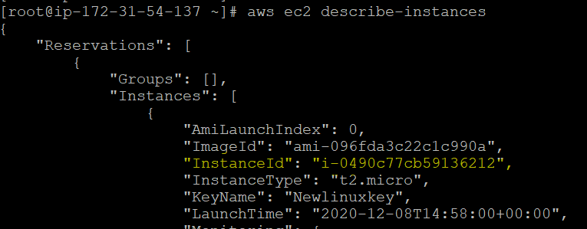

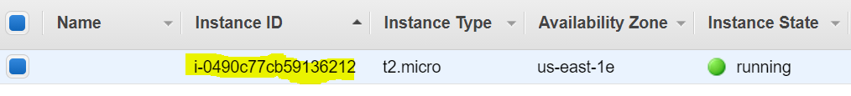

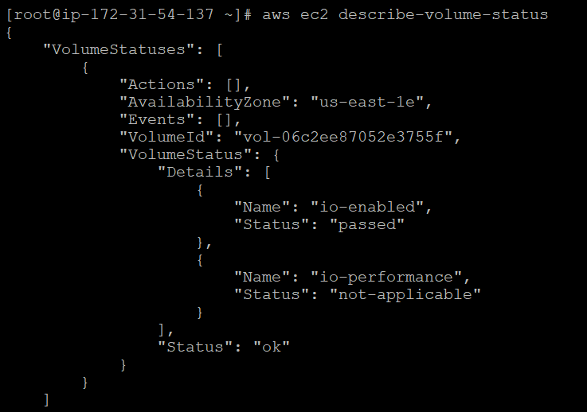

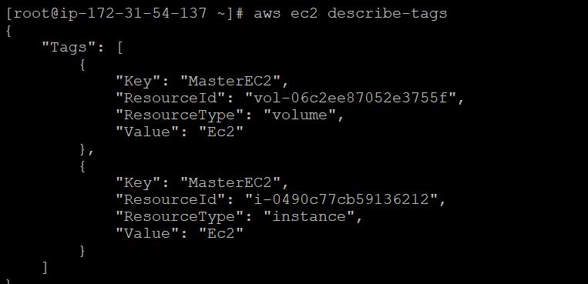

**AWS CLI commands**

# aws ec2 describe-instances

# aws ec2 describe-volume-status

# aws ec2 describe-tags

# aws ec2 describe-security-groups

# aws configure get region

**Create the new instance via CLI and validate once it launched.**

# aws ec2 run-instances --image-id ami-096fda3c22c1c990a --count 1 --instance-type t2.micro --key-name Newlinuxkey --security-group-ids sg-0201c1c805c8b007f

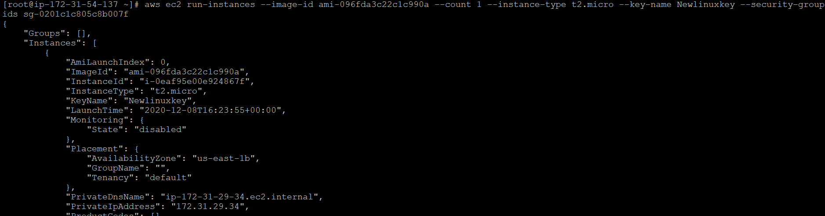

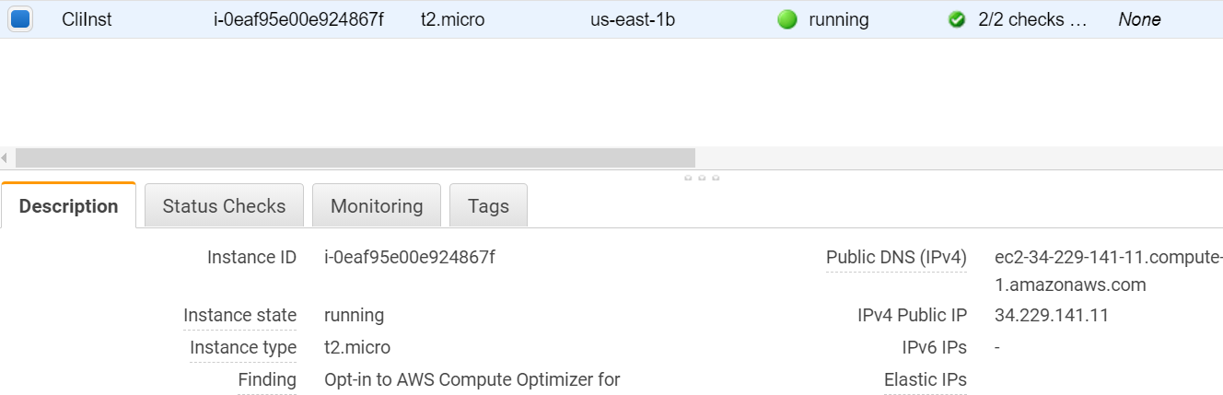

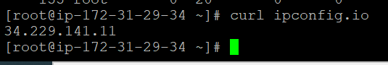

**Start the instance**

# aws ec2 start-instances --instance-ids i-0eaf95e00e924867f

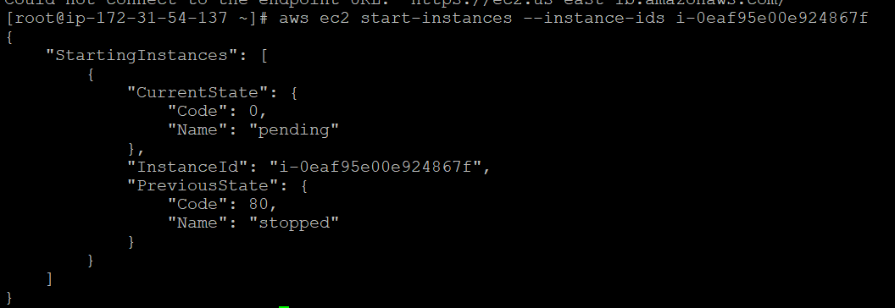

**Terminate the instance**

# aws ec2 terminate-instances --instance-ids i-0eaf95e00e924867f

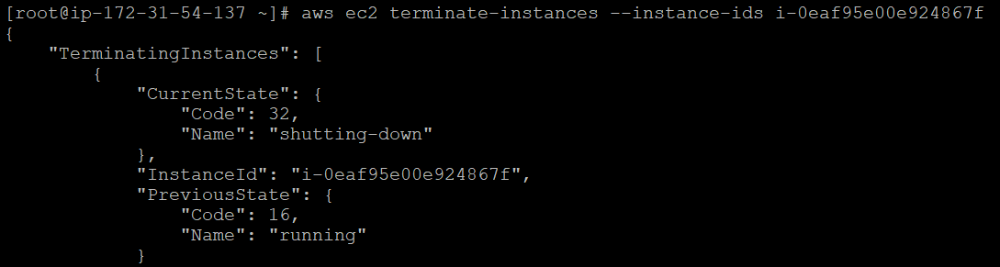

**Valid instance state code**

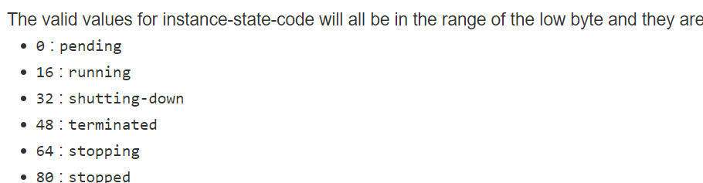

**AWS service management commands:**

# aws ec2 start-instances --instance-ids i-0eaf95e00e924867f

# aws ec2 stop-instances --instance-ids i-0eaf95e00e924867f

# aws ec2 reboot-instances --instance-ids i-0eaf95e00e924867f

# aws ec2 terminate-instances --instance-ids i-0eaf95e00e924867f